
TITLE OF THE CASE STUDY

BACHELOR OF TECHNOLOGY
in
COMPUTER SCIENCE AND ENGINEERING

Submitted by
Name:Sanku Advika
Serial no.:37
Reg no:2025200128

Under the esteemed guidance of
Dr. S.Rama krishna
Assoicate Professor



Department of Computer Science and Engineering
GITAM School of CSE, GITAM (Deemed to be University)
Hyderabad
2026

YEAR

TABLE OF CONTENTS

S. No. | Description | Page No.
1. | Introduction | 1
2. | Project organization | 1-2
3. | Code | 3-8
4. | Output Screen shots | 8-11
5. | Profile and Github Link | 11-12
6. | References | 12

- INTRODUCTION

NAME OF THE PROJECT:PARKVIK(SMART PARKING SYSTEM)
1.1 Need of the Project
In today’s rapidly growing urban environment, parking has become a major challenge due to the increasing number of vehicles. Finding a parking space manually is time-consuming and inefficient. This leads to:
* Traffic congestion
* Fuel wastage
* Increased pollution
* Driver frustration
To overcome these issues, a smart and automated parking system is required. The *ParkVik Smart Parking System* provides a digital solution where users can easily view, book, and manage parking slots.

1.2 Use of the Case Study*
This project demonstrates how a simple software application can solve real-world parking problems.
Applications include:
* Shopping malls
* Office complexes
* Apartments
* Smart city systems
The system is built using *Python and Tkinter GUI*, making it interactive, user-friendly, and efficient.

2. Project organization
ParkVik/
│
├── main.py # Entry point (runs the app)
├── config.py # Constants (file names, colors, etc.)
│
├── data/
│ ├── users.json
│ └── slots.json
│
├── assets/
│ └── car.png
│
├── utils/
│ ├── __init__.py
│ └── storage.py # load/save JSON functions
│
├── core/
│ ├── __init__.py
│ └── app.py # Main ParkVik class
│
├── ui/
│ ├── __init__.py
│ ├── components.py # buttons, entries, cards
│ ├── screens.py # login, register, dashboard, etc.
│ └── animations.py # fade, hover effects
│└── README.md

3. CODE
3.1. Data Handling
Handles loading and saving of user and slot data safely using JSON.

def load_data(file):
if not os.path.exists(file):
return {}
with open(file, "r") as f:
return json.load(f)

def save_data(file, data):
with open(file, "w") as f:
json.dump(data, f, indent=4)

3.2.Initialize User and Slot Data
Creates empty JSON files for initial setup.

def init_users():
save_data(USERS_FILE, {})
def init_slots():
slots = {f"SLOT{i}": None for i in range(1, 11)}
save_data(SLOTS_FILE, slots)

3.3. Class Initialization
The main class builds the window, handles fade-in animation, and sets up data.

class ParkVik:
def __init__(self, root):
self.root = root
self.root.title("ParkVik 🚗")
self.root.geometry("360x640")
self.root.configure(bg="#0f172a")
self.root.resizable(False, False)
self.user = None
if not os.path.exists(USERS_FILE):
init_users()
if not os.path.exists(SLOTS_FILE):
init_slots()
self.load_images()
self.fade_in()
self.home()

3.4. Fade-in Animation (UI Polish)
Creates a smooth start animation effect for the app window.

def fade_in(self):
for i in range(0, 100):
self.root.attributes("-alpha", i/100)
self.root.update()
self.root.after(5)

3.5. Dynamic UI Helpers
Reusable methods for widgets—cleaner and modular UI design.

def card(self):
frame = tk.Frame(self.root, bg="#1e293b")
frame.pack(pady=12, padx=15, fill="x")
return frame

def button(self, parent, text, cmd, color, hover):
btn = tk.Button(parent, text=text,
bg=color, fg="white",
font=("Segoe UI", 11, "bold"),
relief="flat", height=2,
command=cmd)
btn.pack(fill="x", pady=6)
self.hover_effect(btn, color, hover)

3.6. Authentication
Simple login and registration system using file-based data.
Register:
def register(self):
...
def do_register():
users = load_data(USERS_FILE)
if user.get() in users:
messagebox.showerror("Error", "User exists")
else:
users[user.get()] = {"password": pwd.get()}
save_data(USERS_FILE, users)
messagebox.showinfo("Success", "Account created!")
self.home()

Login:
def login(self):
def do_login():
users = load_data(USERS_FILE)
if user.get() in users and users[user.get()]["password"] == pwd.get():
self.user = user.get()
self.dashboard()
else:
messagebox.showerror("Error", "Invalid login")

3.7. Slot Booking System
Displays 10 parking slots and manages booking/payment simulation.

def slots(self):
self.clear()
self.title("Select Slot")
slots = load_data(SLOTS_FILE)
grid = tk.Frame(self.root, bg="#0f172a")
grid.pack()
for i, (slot, user) in enumerate(slots.items()):
num = slot.replace("SLOT", "")
color = "#22c55e" if user is None else "#38bdf8" if user == self.user else "#ef4444"
def book(s=slot):
if slots[s] is not None:
messagebox.showerror("Error", "Booked")
return
if messagebox.askyesno("Payment", "Pay ₹50?"):
slots[s] = self.user
save_data(SLOTS_FILE, slots)
self.slots()

8. Cancel Booking
Lets users cancel only their booked slots.

def cancel(self):
self.clear()
self.title("Cancel Booking")
slots = load_data(SLOTS_FILE)
my = [s for s, u in slots.items() if u == self.user]
if not my:
tk.Label(self.root, text="No bookings found", bg="#0f172a", fg="white").pack(pady=10)
for s in my:
def cancel_slot(slot=s):
slots[slot] = None
save_data(SLOTS_FILE, slots)
self.dashboard()
9. Run Application

root = tk.Tk()
app = ParkVik(root)
root.mainloop()

4. OUTPUT SCREEN
4.1 Home Screen
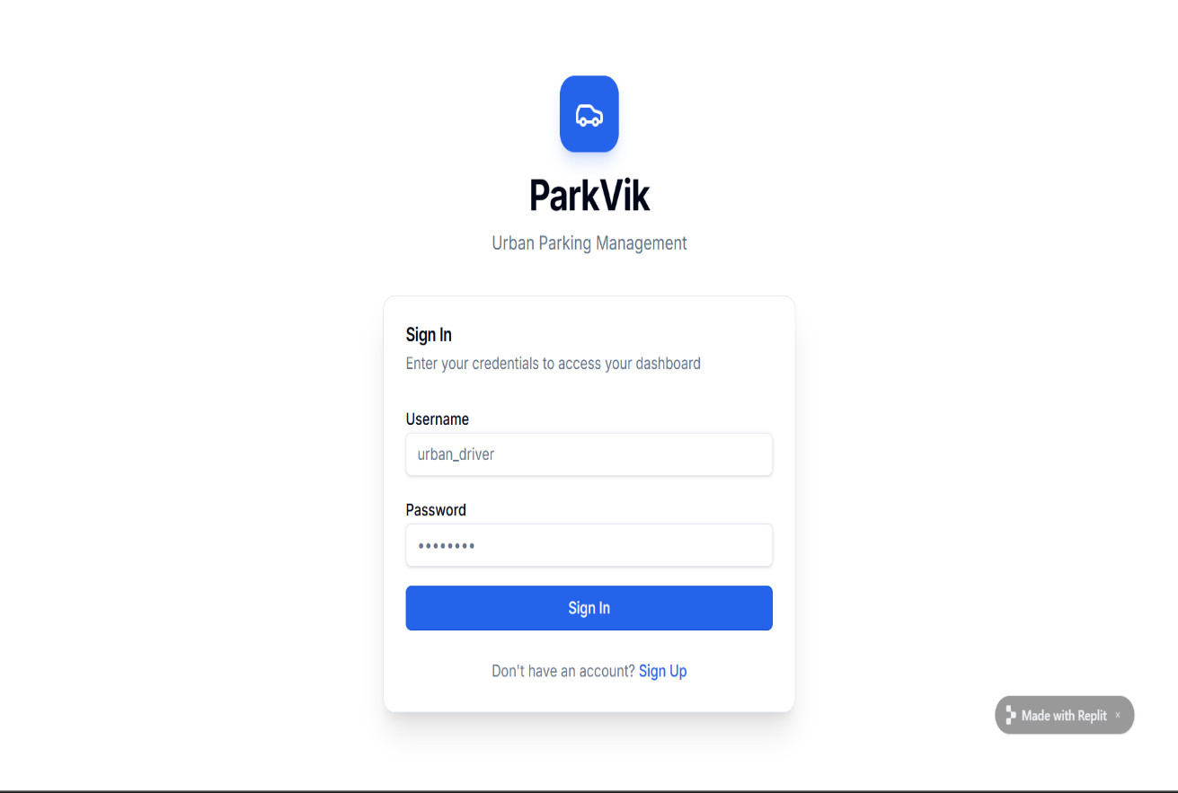

4.2 Dashboard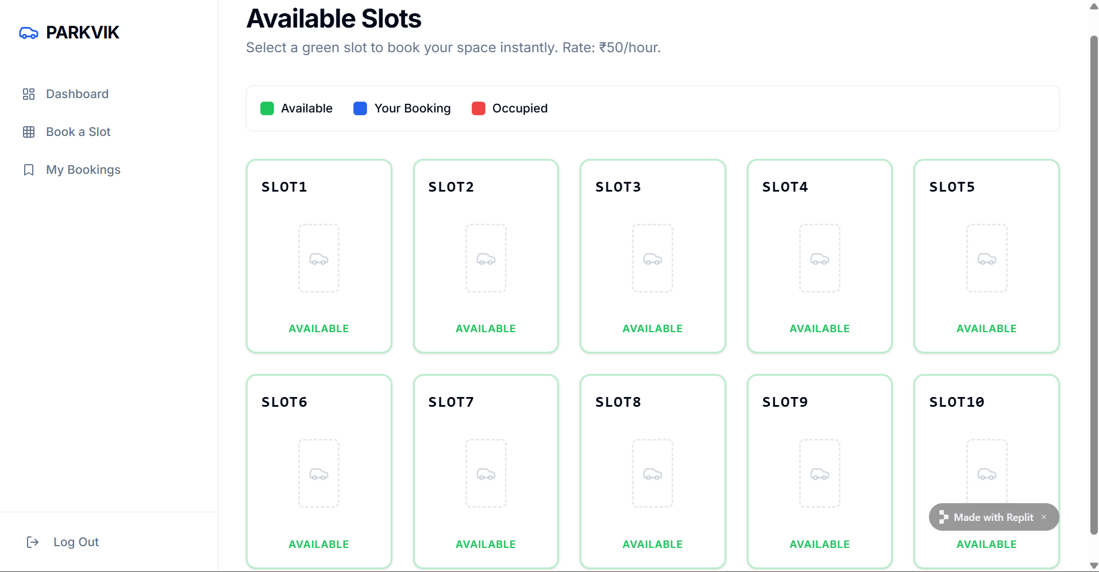

4.3 Slot Selection


4.4 Payment
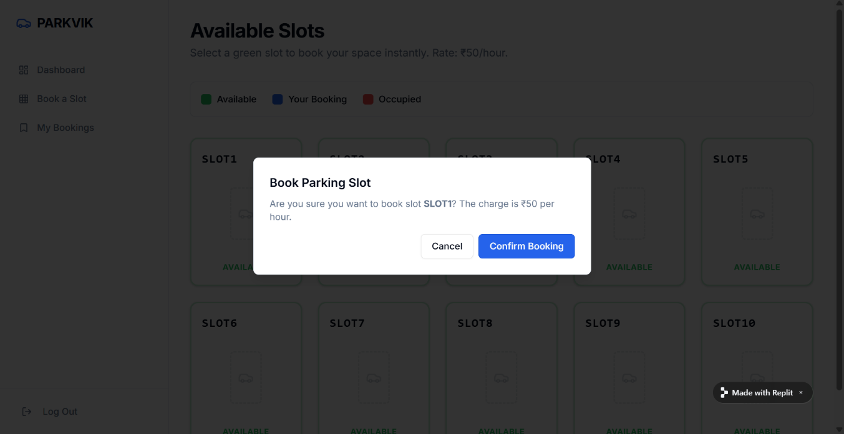

4.5 My bookings
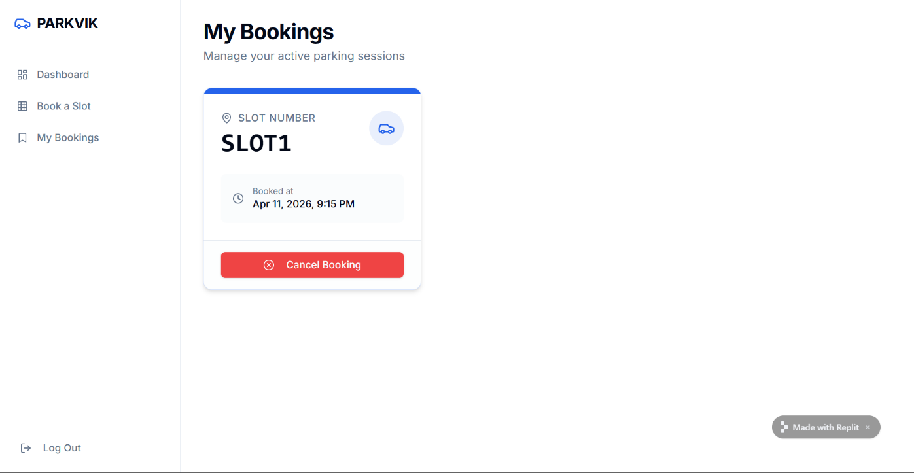

4.6Cancel Booking
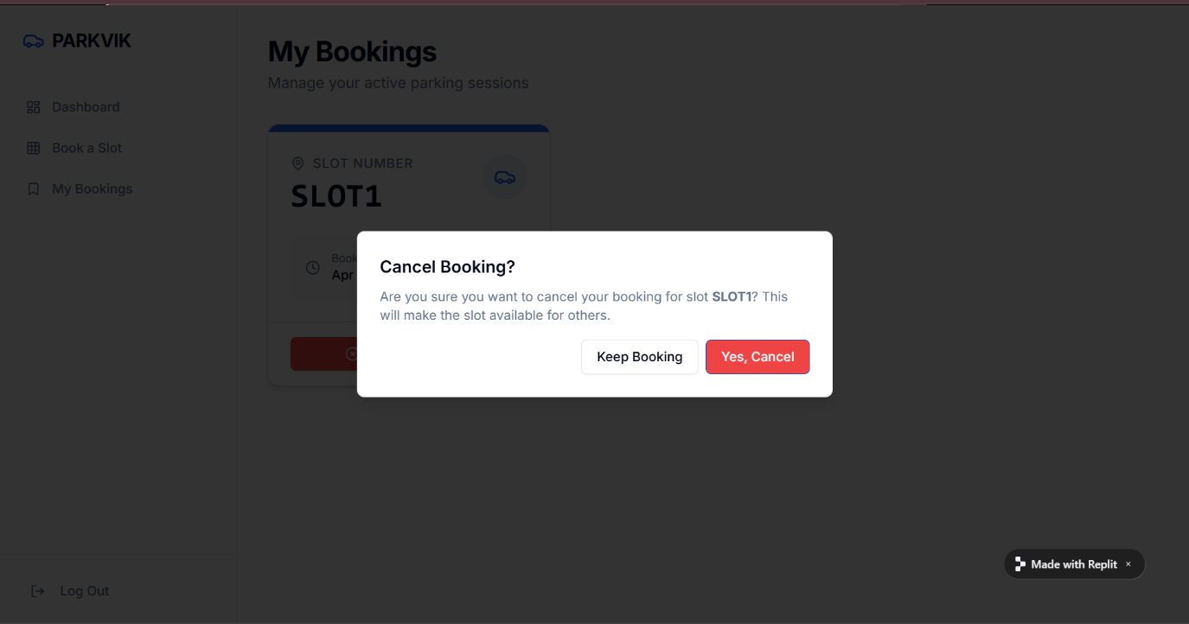

5.FINAL SECTION
Photo


GitHub Account
GitHub Profile: Advikasanku
Repository Link: https://github.com/Advikasanku/Parkvik.git
Replit link(website): https://e55090dd-1eb3-4f2f-9aae-cffcf86bf437-00-1vyqnfl5cwmi7.spock.replit.dev/

6.References:
Chat Gpt
Copilet
Replit



